# **CAPSTONE Project**: How Effective is Consumer Financial Protection Bureau protecting all consumers from unscrupulous practices from financial services providers?

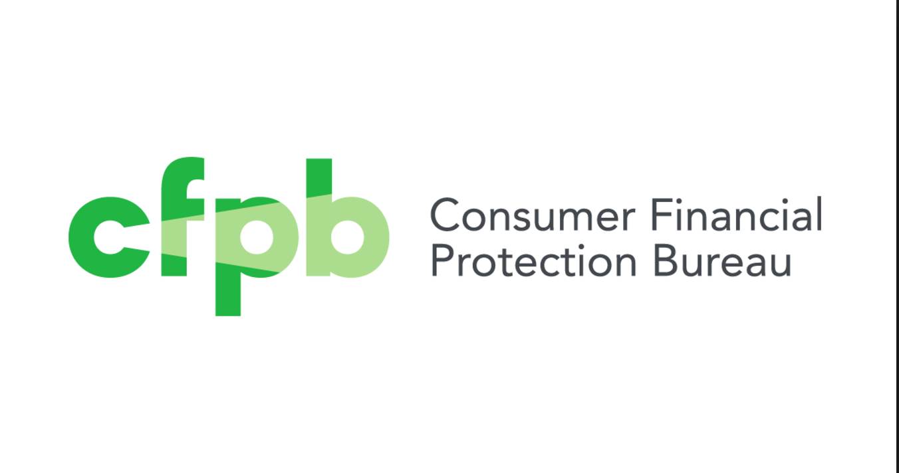

**By: Natasha Medina**

Contents:

Objective

1. Introduction-Background
   1. Data source of Project
   2. Aim of the project
   3. Oddities in the Project
2. Data Wrangling
   1. Adjustments
3. Exploring relationships between the variables
4. Applying various forecasting models
   1. Sentiment Analysis
   2. Association Analysis
   3. Word Cloud

**Objective:** Improving and Gathering Insights from Consumer Complaints from Consumer Federal Protection Bureau

1. **Introduction- Background:**

Various financial industries are affected by higher consumer confidence index which measures how optimistic U.S. consumers are at a specific point in time. While economists and investors can debate just how significant this indicator is, most at least grudgingly agree that how consumers feel about the economy (and their personal financial situation can be a self-fulfilling prophecy.

CFPB main objective to eradicate potential unfair, deceptive, or abusive acts or practices(UDAAP) that violate the Consumer Financial Protection Act and other consumer financial laws, the CFPB has broad power to examine the practices both banks and non-banks. And while banks with more than $10 billion in assets fall directly under CFPB regulations, any provider of consumer financial products and services. Recently as of now 2013, it released a complaint narrative

The Publication of Consumer Credit Card complaints adds accountability for the credit card companies. They know that if they act improperly, more people will be aware of it and their reputations will be damaged as result. This will hopefully manifest itself in more consumer-friendly policies and an increased emphasis on resolving problems quickly and fairly.

Consumer Financial Protection Bureau Complaints has set up its own complaints database that any consumer can access to a file complaint that any consumer can access to file a complaint against a financial service provider. So service providers need to ensure their own complaints management systems are serving the needs of customers to avoid becoming a line item in the CFPB’s complaints database. According to Service Insights Blog, states that the intention the regulation is to help banks run a good business and stay competitive and complaint, to meet the credit needs of the consumer while running a sound business.

CFPB states, “by submitting a complaint, consumers can be heard by financial companies, get help with their own issues, and help others avoid similar ones.”(CFPB website) Every complaint provides insight into problems that people are experiencing, helping us identify inappropriate practices and allowing us to stop them before they become major issues. The result: better outcomes for consumers and a better financial marketplace for everyone.

**1a. *Data Source: Consumer Complaint Database API DOCS:***

Each week CFPB send thousands of consumers’ complaints about financial products and services to companies for response. Complaints are listed in the database after the company responds or after they’ve had the complaint for 15.

**1b. *Aim of the Project***

I want to investigate the consumer sentiment towards credit cards. In the recent economy, consumer sentiment is a bit down, more consumers are spending less money. One of the objectives is to see emphasis resolve problems quickly and fairly for consumers. Many consumers are shopping around which companies to use to get a credit card. This database could serve as a tiebreaker to decide between two cards with equal terms. I want to measure the consumer confidence in resolving the credit issue for credit card companies.

Important information in the data set are the text complaints (consumer complaint narrative)

**1c. *Oddities in Data***

1. Interrelated categorical variables
   1. Explanation: According to CFPB dictionary, many categorical variables are dependent on each other. For example, ‘*Sub-Product’* is dependent on ‘*Product’* and not all ‘*Product’*  have ‘*Sub-Product’*. This is resulted from the data collection mechanism(i.e. the procedure of filing a complaint) which involved a ‘display logic’ among categorical variables: choose product from a set list of options, than choose the sub-product from a list of options based on the product selected etc.
   2. Solution: This gives me insight when I start the cleaning process, that I need
2. Irregular value in ‘Zip Code’
   1. Explanation: the values of zip codes is XXX23, to protect privacy for customers.
   2. Solution:
      1. Zip codes are used to validated the geographical analysis, and since the ‘State’ abbreviations in the dataset has been validated, we can use the ‘State’ variable for potential geographical analysis

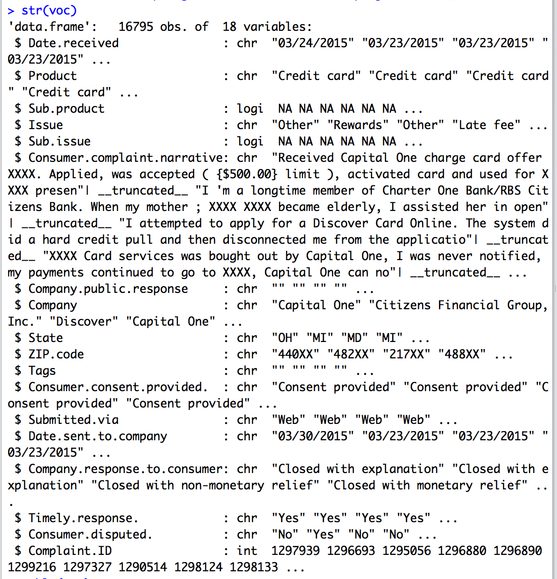

The important data fields I discovered were the Consumer Complaint. Narrative where it describes consumer financial information such as Zip Code, Address, and many more.

There were a couple of variables not relevant to the Credit Card section such as Sub Issue and Sub Product for the text mining analysis.

#### **Text Characteristics:**

There are two kinds of text characteristics dependency, ambiguity, noisy data, not well structure text. Dependency is relevant information is complex conjunction of word and phrases. Ambiguity can be identified as either word ambiguity such as pronouns, buy, or semantic ambiguity. While I was conducting my text mining analysis on CFPB I went through all four text characteristics.

### **Data Wrangling:**

The dataset is relatively clean because it was compiled through the regular scrapings of CFPB website. However, due to privacy regulations from Dodd-Franksen. The information published CFPB is considered PPI type of document.

**Algorithm Method:**

Text Mining or Text Analytics applies tools to learn from collections of text documents. The objective is similar to humans learning by reading books. Using automated algorithms, we can learn from massive amounts of text, much more than a human can.

There are several packages required in order to perform text analytics

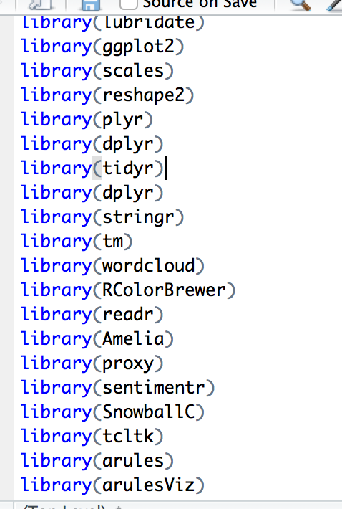

**Inspect Provided Dataset:**

One of the first initial stages of data cleaning is the inspect the data to see what is given from the API of CFPB.

I used the glimpse function to see an overview of the data, 16 variables, rest are character except for complaint id which is an integer.

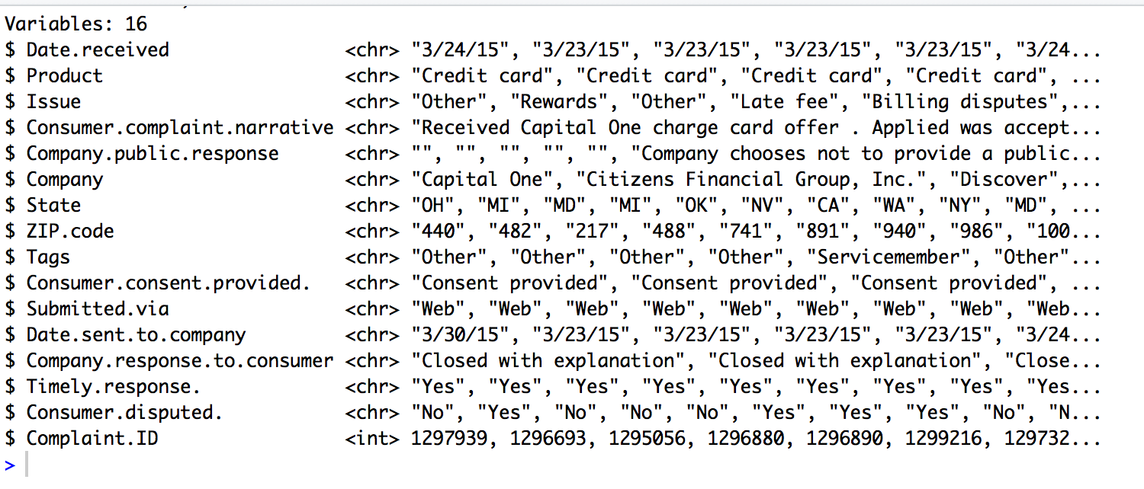

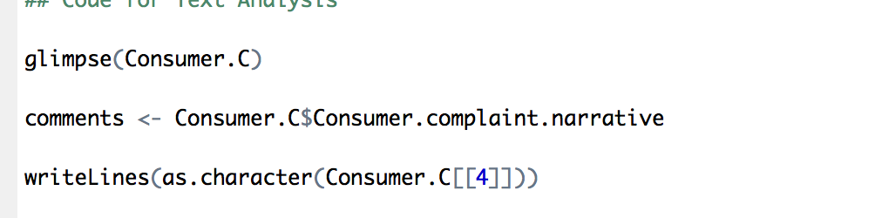

**Pre-Processing:**

The first task is to put the text files in one structured file referred to as a Corpus. The number of documents could be just one, or dozens. With the corpus created, the data preparation can begin with the text presentation.

Some common and useful transformations for text files:

* Change capital letters to lower case
* Remove numbers
* Remove Stopwords
* Remove excess white space
* Word stemming
* Word replacement

Once the corpus has been transformed, it’s a not only a more compact dataset, but simplifies the structure in order to facilitate relationships among the words, thereby leading to an increased understanding.

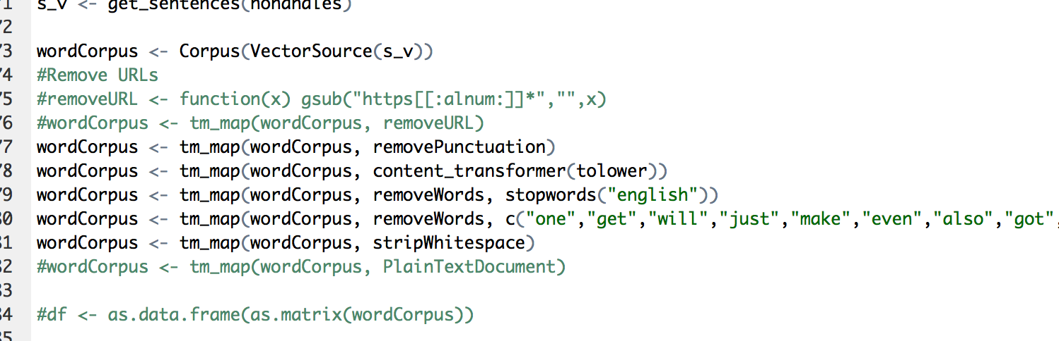

With the transformation of corpus completed, the next step is to create a Term-Document Matrix. TDM is a matrix of word counts for each individual document in the matrix. A TDM would have the document as columns, and the words. With a matrix, you can begin to analyze the text by examining the word counts and producing visualizations such as word clouds. Also another method I plan on using is word associations by producing correlation lists for specific words.

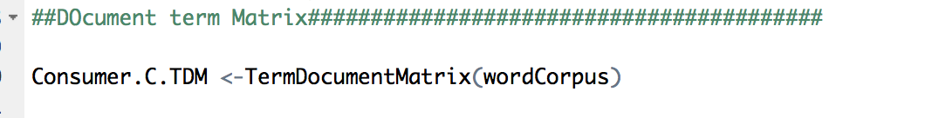

***Exploring Relationship between variables***

***Companies:***

Now let’s move to the companies that received highest number of complaints:

It is no surprise that the highest level of complaints received by companies is CitiBank, Capital One, JP Morgan Chase, and Synchrony Financial Bank.

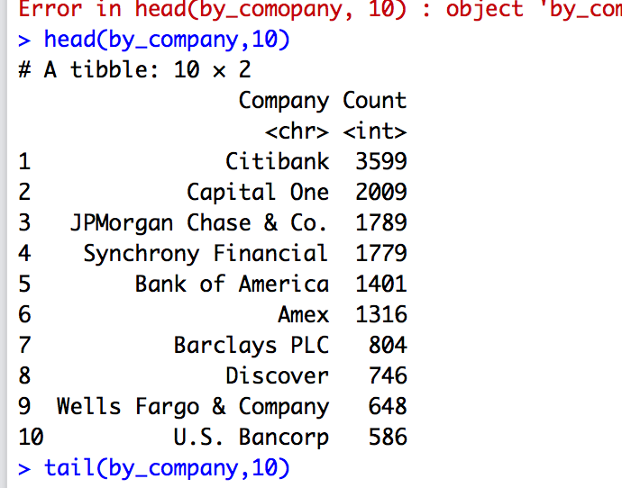

Top 10 Companies receiving consumer complaints are no surprise are big banks such as Citibank, Capital One, JP Morgan Chase & Co, and Synchrony Financial.

I found it surprising that Discover and Wells Fargo has the least amount compared to big banks of Capital One who proud themselves of striving innovating customer service and experiencing using their financial service products.



These are the companies with the least number of complaints. It does not come to surprise that it is a unknown banks except for UBS bank.

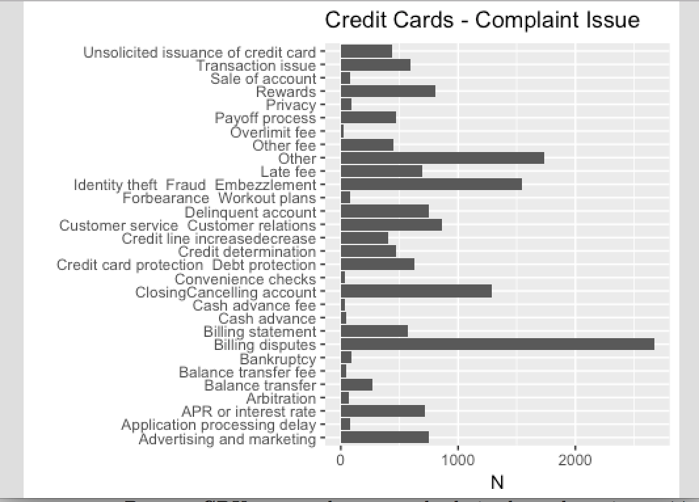

This graph depicts the consumers top issues: billing disputes, identity theft, other, late fee, and closing/canceling account. From what I depict

How many different companies?

What are the top 10 and bottom 10 companies based on the number of complaints?



Biggest banks have thousands of complaints as my table figure said earlier.

I want to take a look at the distribution of complaints across the country.

States:

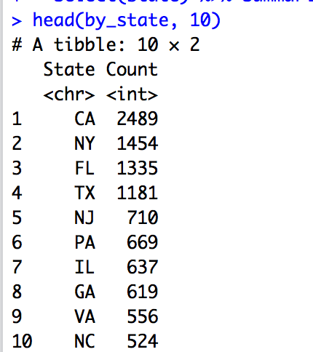

California, New York, Florida, Texas have the highest complaints in the four figures. Does that mean consumers are more aware of CFPB help to aid consumers to get their issue down rather than other states that are issued less?

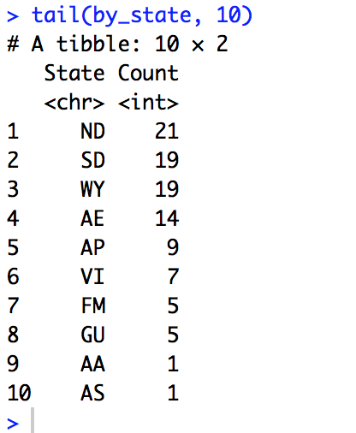

There are more than 50 states in the state column. These even include even the federal as well as inhabited territories. Also the states with most complaints look like the ones who are highly populated across states of the country. The states with lowest complaints are lowest populated states across the country.



There are more than 50 states in the State Column. These include even the federal as well inhabited territiories. Also, the states with most complaints look likes the ones which are highly populated.

Timely Response: How many complaints have received timely response?

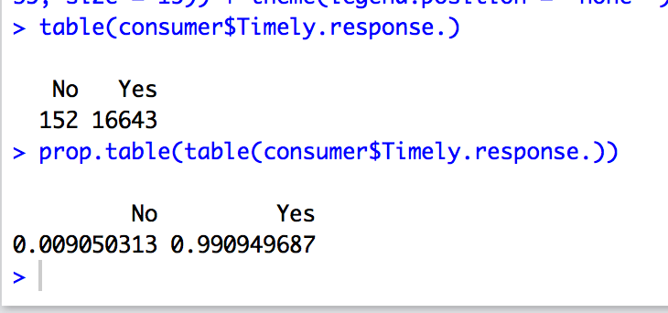

Almost 98% of the complaints have been addressed timely. Given the competition in the financial sector and also the challenges posed by the Fintech established players have to do lot more to resolve the complaints.

Consumer Disputed: How many consumers disputed?

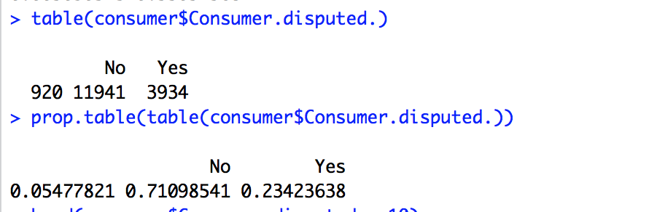



All companies: Majority of the complaints are filed through the web none are used referral phone th

## Time Taken to Sent the Complaint To Company

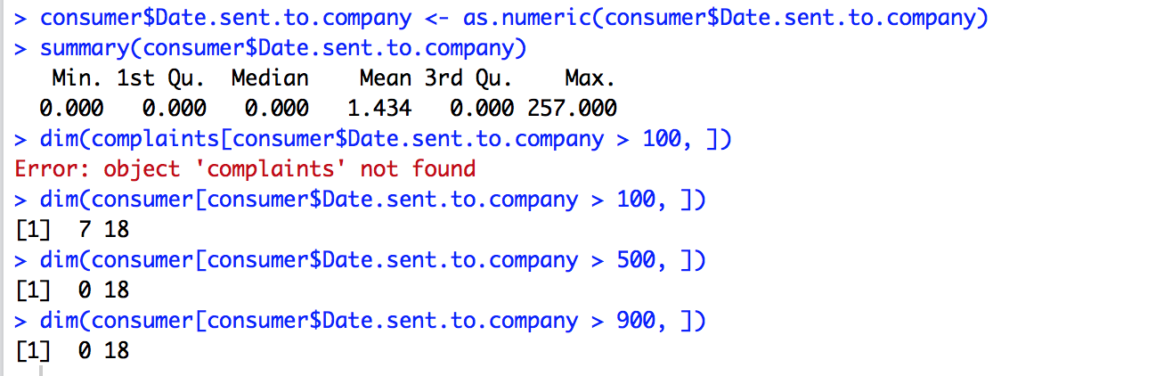

Very surprising that it took more than 100 days for 3K complaints to be sent to companies.

There are also some data entry issues where the days took is in negative. Date received is after the date sent which is a data entry issue.

One complaint took 900 days to be sent to company.

## Create New Variable Month and Year

Sentiment Analysis:

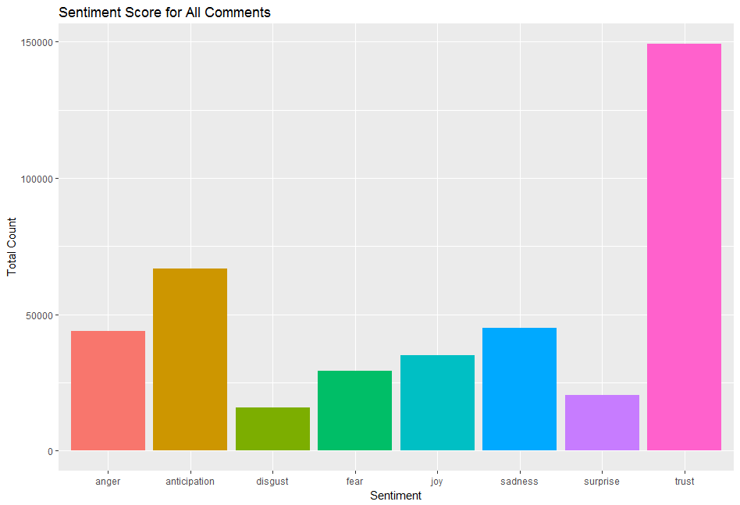

The above is the sentiment Analysis of the responses, it clearly indicates though there is a trust in the system that the issue will get resolved, However it is worrying to see that Emotions like Anger, Disgust, Fear and Sadness are also significant, which clearly indicate that the overall customer responsiveness including the quality and speed of customer grievance tackling needs to be improved significantly.

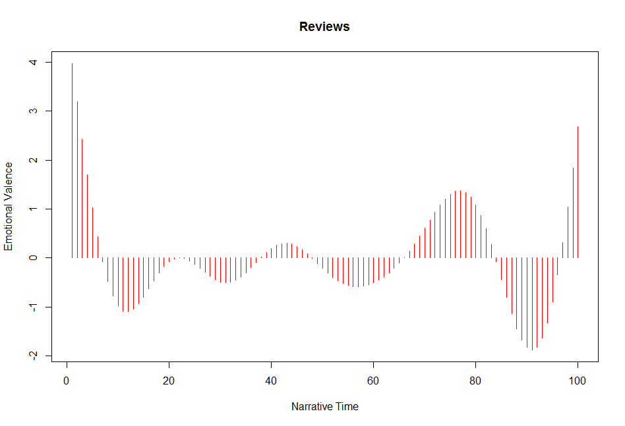

The above emotional Valence analysis seems to further indicate that customer grievance management has not been very consistent as we can see significant swings in the value of Emotional Valence, Hence it is recommended that more detailed analysis should be conducted to identify specific pain points for customers and remediation programs must be launched with specific timelines in mind.

Word Frequency and Association Analysis:

Once the Document Term Matrix was set up, I moved on to explore the word frequencies by creating an object with columns sums, sorted in descending order. It is necessary to use as.matrix() in the code to sum the columns. The default order is ascending, so putting – in front of the freq will change it to descending:

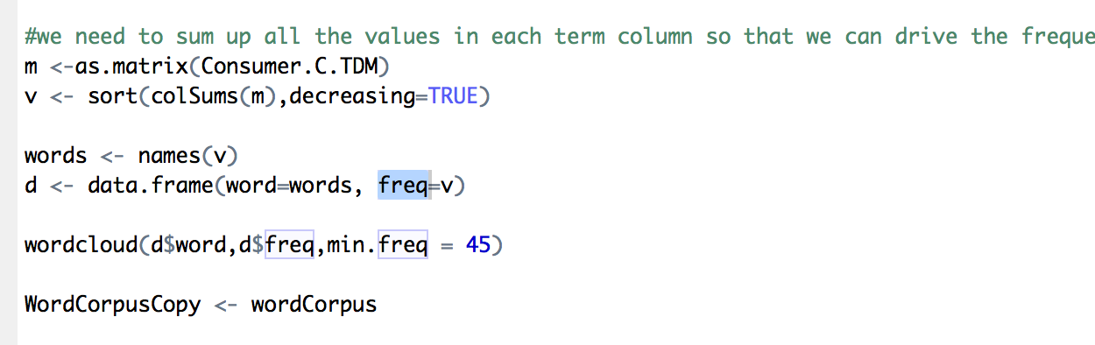

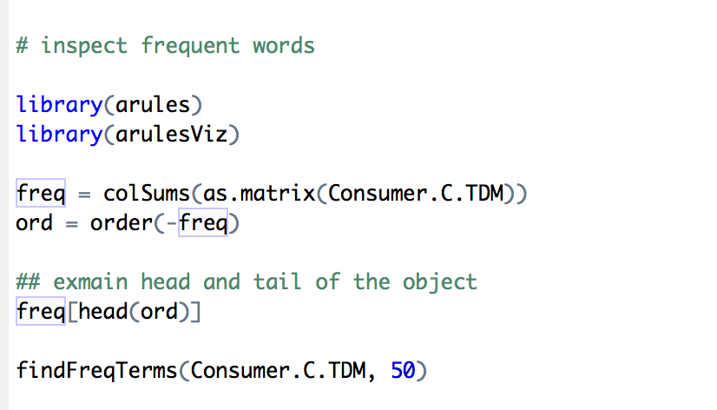

Using findFreqterms(), we can see what words occurred at least 50 times. Looks like

While conducting Association Analysis based on the wordcloud results on the most frequent terms that appear on the consumer complaints narrative. I tried to detect the likely association of the consumer complaints from the database. It seems if I use the term fee it is 40 percent, and pay 15 percent.

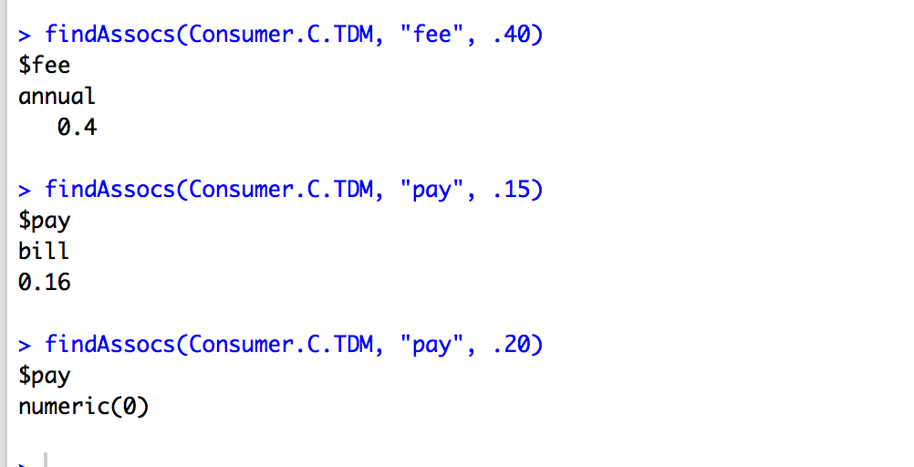

Let’s look at the CFPB consumer complaint narrative most frequent words, one of them is fee using correlation of .40,

Annual is the most frequent word, pay bill with a correlation of .16, pay associated with numeric.



After conducting many associations between terms such as fraudulent



The word association frequently with the word business goes along with practices, days, and personal. When I tried to conduct analysis on the word capital, payment and dispute there was not any correlation between any words more of numeric values.



I was trying to figure out which correlations would be able to find words are associated.

Word Cloud:

Word Cloud can be an handy tool when you need to highlight the most commonly cited words in a text using a quick visualization. Word Clouds add simplicity and clarity. The most used keywords stand out better in a word cloud. Word Clouds are potent communication tool, it’s easy to understand to be shared and are impactful.

I loaded the packages Tm, SnowBallC,wordcloud,RColorBrewer. The text is loaded using Corpus() function from text mining ™ package. Corpus is a list of a document.

Before using wordcloud, we find it convenient to perform some transformations to the corpus as its first input and then a function call to a transformation to apply to that corpus. We do not discuss the specifics of the various transformations simply because they are well named as shown in the following code.

Of course I used removeWords to make a custom word list to avoid words are not necessary such as, “the” or “and” which do not add any real substance and simple serve to the connect other words.

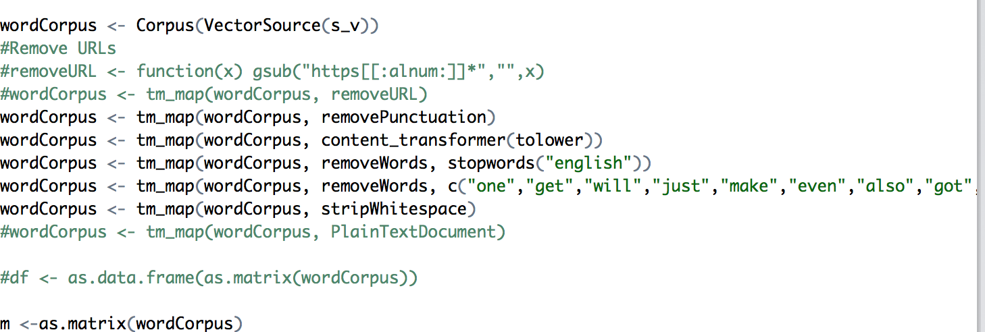

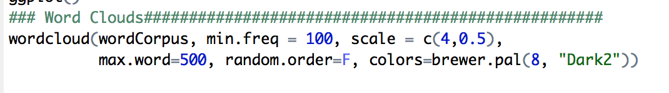

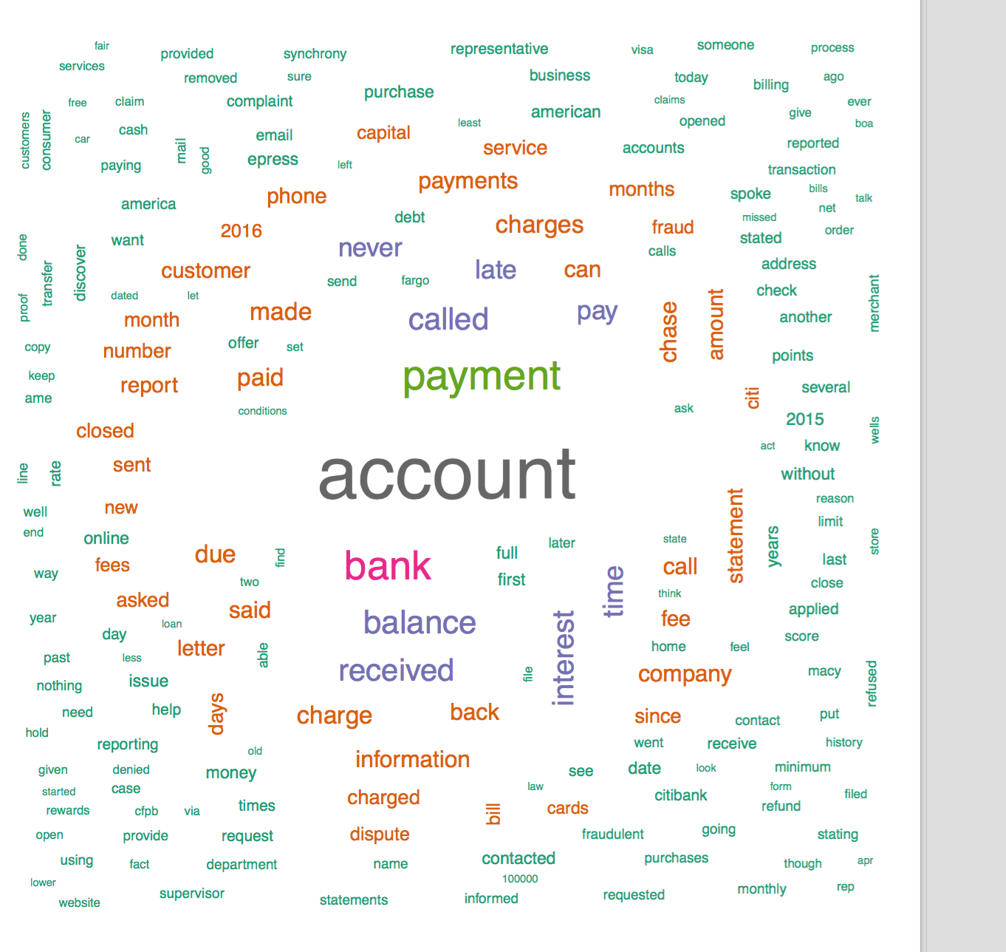

There seems to be a similar theme with consumer letting the CFPB officials know how they feel about credit card issues and hoping the companies being able to fix it.